**BALDIVIS SECONDARY COLLEGE**

** Methods Units 1 and 2**

**2020 Test 1**

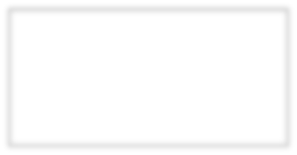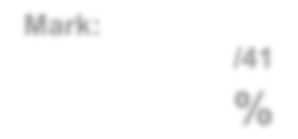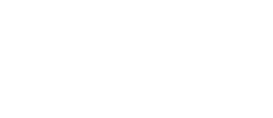

**Mark:**

**/32**

**%**

Student Name _____________________________________________

**Time allowed for this task:** 35 minutes, in-class, test conditions.

Section 1: 10 minutes

Section 2: 25 minutes

**Materials required:** **Section 1** Calculator free section (10 marks)

Standard writing equipment

SCSA Formula Sheet

**Section2** Calculator assumed section (22 marks)

Calculator (to be supplied by the student)

SCSA formula Sheet

One page A4 (double sided) hand written notes

**Other materials allowed:** Drawing templates

**Marks available:** **32 marks**

**Task Weighting: 2%**

**Question 1. [4 marks – 1, 1, 1, 1]**

Use the diagram of a 20o angle on a unit circle provided to **estimate** the following values to two decimal places;

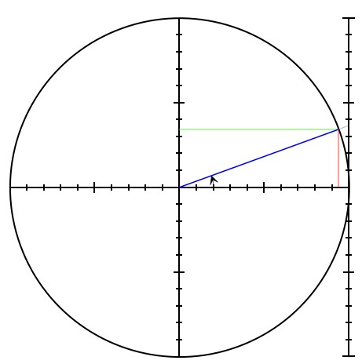

1. cos 20o

1. sin 20o

1. sin 160o

1. tan 160o

**Question 2** **[3 marks]**

Complete the table using exact values:

|  |  |  |  |
| --- | --- | --- | --- |
| Angle | Sin | Cos | Tan |
| 150˚ |  |  |  |
| 300˚ |  |  |  |

**Question 3 [3 marks]**

The triangle shown below has an area of 36 cm2, determine the value of x.

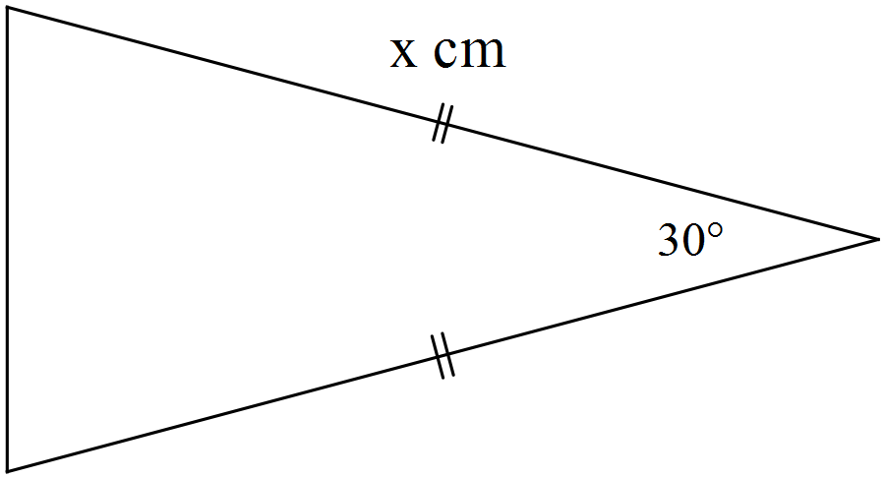

$$6cm$$

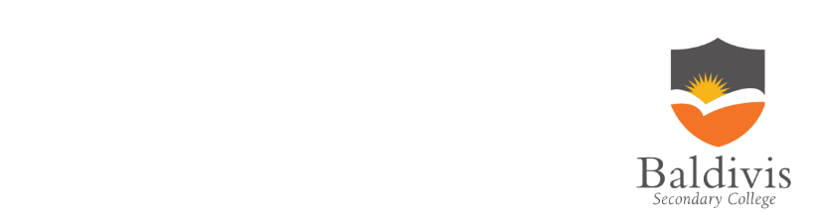

**AEMAM Unit 1 – Test 1 – 2020**

**Name: Time allowed – 25 minutes**

**Calculator Assumed Section (1xA4 page of double sided notes and approved**

**calculators. Formula sheet provided.) – 22 marks**

**Question 4 [8 marks – 3, 2, 3]**

1. Show that the smallest angle in a 5 cm, 8 cm, 11 cm triangle is 24.6o.

1. Hence, or otherwise, determine the area of the triangle.

1. Use the **Sine Rule** to determine the size of the angle opposite the 8cm side.

**Question 5** **[6 marks]**

Determine, correct to 2 decimal places, the length of side BD in the diagram below.

Note: Diagram not drawn to scale.

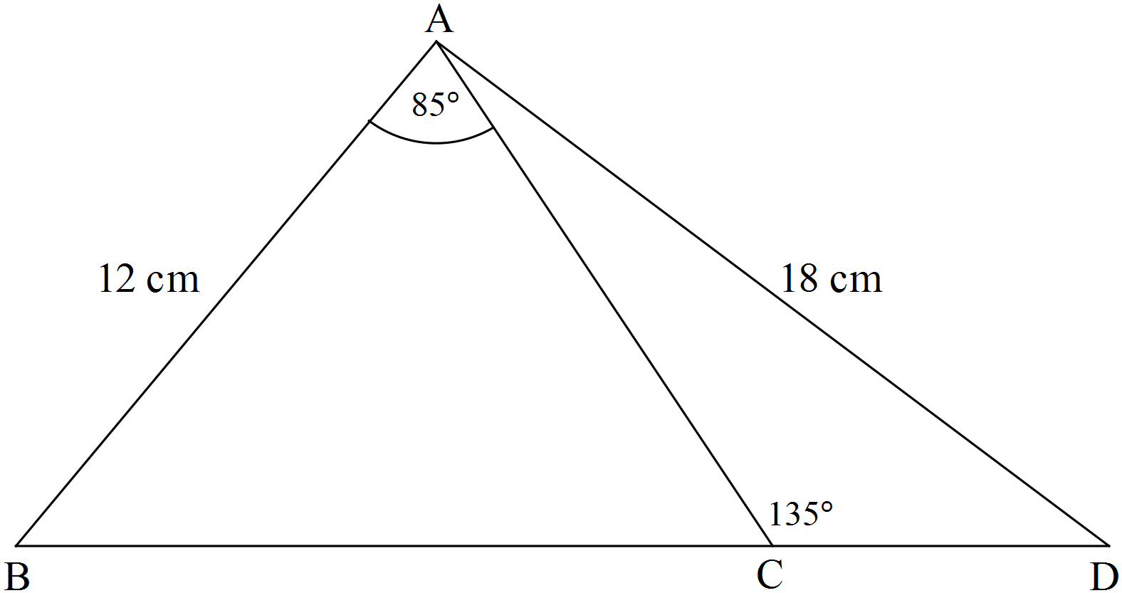

**Question 6 [8 marks]**

In triangle ABC, A = 30o, a = 5 and c = 7.

Find the difference in the two possible areas for ∆ABC.

*Hint: Draw a labelled diagram*

**END OF ASSESSMENT**